2DSCALING

#include <GL/glut.h>
#include <iostream>
#include <math.h>
using namespace std;
void findnewcoordinate(int s[][2], int p[][1]){
int temp[2][1] = {0};
for (int i = 0;i<2;i++)
for(int j = 0;j<1;j++)
for (int k = 0;k<2;k++)
temp[i][j] += (s[i][k] * p[k][j]);
p[0][0] = temp[0][0];
p[1][0] = temp[1][0];
}
void scale(int x[], int y[], int sx, int sy){
glBegin(GL_LINE_LOOP);
glVertex2f(x[0],y[0]);
glVertex2f(x[1],y[1]);
glVertex2f(x[1],y[1]);
glVertex2f(x[2],y[2]);
glVertex2f(x[2],y[2]);
glVertex2f(x[0],y[0]);
glEnd();
int s[2][2] = {sx, 0, 0, sy};
int p[2][1];
for(int i = 0;i<3;i++){
p[0][0]=x[i];
p[1][0]=y[i];
findnewcoordinate(s,p);
x[i] = p[0][0];
y[i] = p[1][0];
}
glBegin(GL_LINE_LOOP);
glVertex2f(x[0],y[0]);
glVertex2f(x[1],y[1]);
glVertex2f(x[1],y[1]);
glVertex2f(x[2],y[2]);
glVertex2f(x[2],y[2]);
glVertex2f(x[0],y[0]);
glEnd();
glFlush();
}
void init(void){
glClearColor(0.0,0.0,0.0,0.0);
gluOrtho2D(0,500,0,500);
}
int main(int argc ,char** argv) {
int x[] = {100,200,300};
int y[] = {200,100,200};
int sx = 2,sy = 2;

glutInit(&argc, argv);
glutInitDisplayMode(GLUT_SINGLE | GLUT_RGB);
glutInitWindowSize(640, 480);
glutInitWindowPosition(0,0);
glutCreateWindow("2Dscaling");
init();
scale(x,y,sx,sy);
glutMainLoop();
return 0;

}

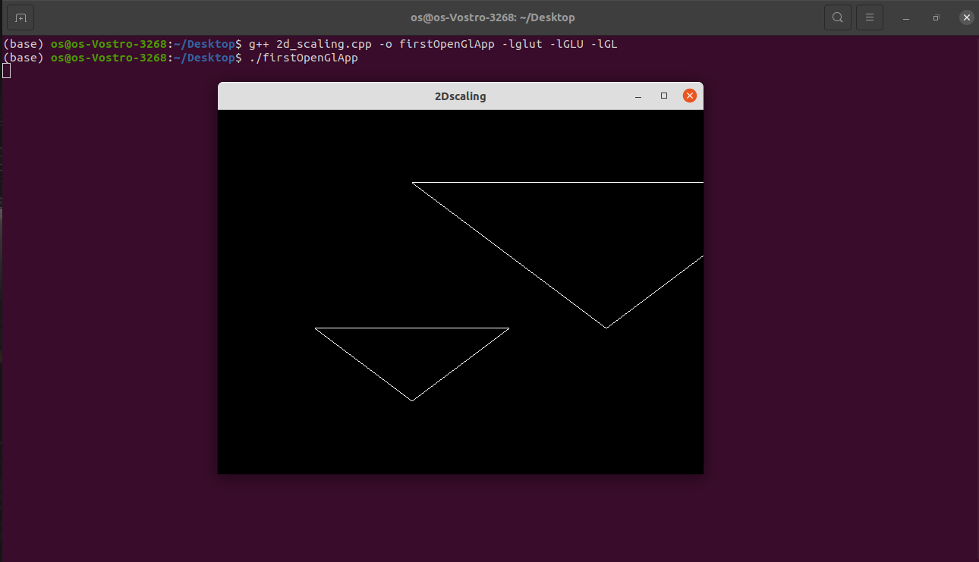

2DTRANSLATION

#include<GL/glut.h>
#include <iostream>
#include <math.h>
using namespace std;
void translateRectangle(int P[][2], int T[]){
glBegin(GL_LINE_LOOP);
glVertex2f(P[0][0], P[0][1]);
glVertex2f(P[1][0], P[0][1]);
glVertex2f(P[1][0], P[1][1]);
glVertex2f(P[0][0], P[1][1]);
glEnd(); // calculating translated coordinates
P[0][0] = P[0][0] + T[0];
P[0][1] = P[0][1] + T[1];
P[1][0] = P[1][0] + T[0];
P[1][1] = P[1][1] + T[1];
glBegin(GL_LINE_LOOP);
glVertex2f(P[0][0], P[0][1]);
glVertex2f(P[1][0], P[0][1]);
glVertex2f(P[1][0], P[1][1]);
glVertex2f(P[0][0], P[1][1]);
glEnd();
glFlush();
}
void init(void){
glClearColor(0.0, 0.0, 0.0, 0.0);
gluOrtho2D(0, 500, 0, 500);
}
int main(int argc, char** argv){
int P[2][2] = { 50, 80, 120, 180 };
int T[] = { 100, 100 }; // translation factor
glutInit(&argc, argv);
glutInitDisplayMode(GLUT_SINGLE | GLUT_RGB);
glutInitWindowSize(640, 480);
glutInitWindowPosition(0, 0);
glutCreateWindow("2D Transformaton Scaling ");
init();
translateRectangle(P, T);
glutMainLoop();
return 0;
}

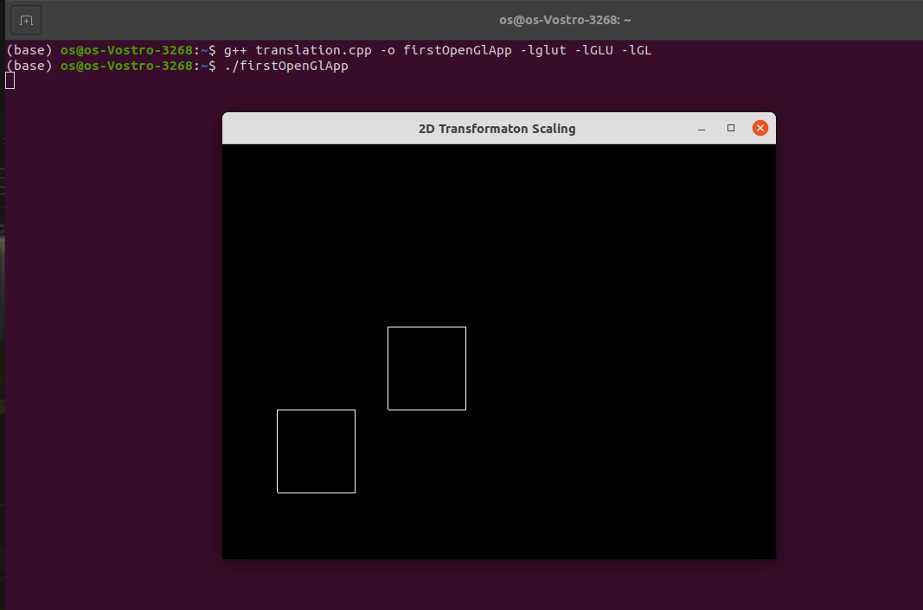

BOUNDARY FILL

#include<GL/glut.h>
#include<iostream>
#include<math.h>
int ww = 600, wh = 500;
float fillCol[3] = {0.4,0.0,0.0};
float borderCol[3] = {0.0, 0.0,0.0};
void setPixel(int pointx, int pointy, float f[3])
{
glBegin(Gl_POINTS);
glColor3fv(f);
glVertex2i(pointx,pointy);
glEnd();
glFlush();
}
void getPixel(int x, int y, float pixels[3])
{ glReadPixels(x, y, 1.0, 1.0,GL_RGB, GL_FLOAT,pixels);
}

void drawPolygon(int x1,int y1,int x2,int y2)
{
glColor3f(0.0,0.0,0.0);
glBegin(GL_LINES);
glVertex2i(x1,y1);
glVertex2i(x1,y2);
glEnd();
glBegin(GL_LINES);
glVertex2i(x2,y1);
glVertex2i(x2,y2);
glEnd();
glBegin(GL_LINES);
glVertex2i(x1,y1);
glVertex2i(x2,y1);
glEnd();
glBegin(GL_LINES);
glVertex2i(x1,y2);
glVertex2i(x2,y2);
glEnd();
glFlush();
}
void display(){

glClearColor(0.6,0.4,0.1,1.0);
glClear(GL_COLOR_BUFFER_BIT);
drawPolygon(150,250,200,300);
glFlush();
}

void boundaryFill4(int x,int y,float fillColor[3],float borderColor[3])
{
float interiorColor[3];
getPixel(x,y,interiorColor);

if ((interiorColor[0] != borderColor[0] && interiorColor[1] != borderColor[1] && interiorColor[2] != borderColor[2])&& (interiorColor[0] != fillColor[0] && interiorColor[1] != fillColor[1] && interiorColor[2] != fillColor[2]))

{
setPixel(x,y,fillColor);
boundaryFill4(x,y-1,fillColor,borderColor);
boundaryFill4(x,y+1,fillColor,borderColor);
boundaryFill4(x+1,y,fillColor,borderColor);
boundaryFill4(x-1,y,fillColor,borderColor);

}
}

void mouse(int btn, int state, int x ,int y)
{
if(btn == GLUT_LEFT_BUTTON && state == GLUT_DOWN)
{
int xi = x;
int yi = (wh - y);
boundaryFill4( xi , yi , fillCol, borderCol);
}
}
void myinit()
{
glViewport(0,0,ww,wh);
glMatrixMode(GL_PROJECTION);
glLoadIdentity();
gluOrtho2D(0.0,(GLdouble)ww,0.0,(GLdouble)wh);
glMatrixMode(GL_MODELVIEW);
}
int main (int argc , char **argv)
{
glutInit(&argc,argv);
glutInitDisplayMode(GLUT_SINGLE|GLUT_RGB);
glutInitWindowSize(ww , wh);
glutCreateWindow("Boundry Fill Recursive");
glutDisplayFunc(display);
myinit();
glutMouseFunc(mouse);
glutMainLoop();
return 0;
}

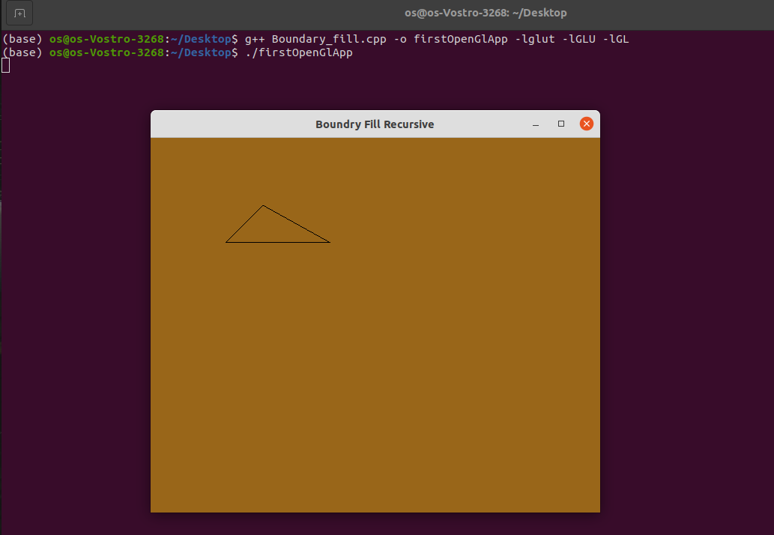

BRESENHAM LINE

#include<iostream>
#include<GL/glut.h>
#include<math.h>
using namespace std;
float r,g,b,x,y;
float x_1,x_2,y_1,y_2;

bool flag = true;

void mouse(int button , int state, int mousex, int mousey){
if(button == GLUT_LEFT_BUTTON && state == GLUT_DOWN){
flag = true;
x = mousex;
y = 480-mousey;
}
cout<<"mousex = "<<x;
cout<<"mousey = "<<y;
}

int sgn(float a){
if(a==0){
return 0;
}
if(a<0){
return -1;
}
else{
return 1;
}
}

void Line(){
cout<<"x_1=" << x_1 <<"y_1=" << y_1;
cout<<"x_2=" << x_2 <<"y_2=" << y_2;

float dx,dy,length,G;
//x_2 = x;
//y_2 = y;
dy = y_2 - y_1;
dx = x_2 - x_1;
G = (2*dy)-dx;

if(abs(dx) >= abs(dy)){
length = abs(dx);
}
else{
length = abs(dy);
}
int j =0;
x = x_1;
y = y_1;

while(j <= length){
if(abs(dx) >= abs(dy)){
x = x+1;
if(G>=0){
y = y+1;
G = G+2*(dy-dx);
}
else{
G = G + (2*dy);
}
}
else{
y = y+1;
if(G>=0){
x = x+1;
G = G+2*(dy-dx);
}
else{
G = G+ (2*dy);
}
}
cout<< "\n x = " << x;
cout<< "y = " << y;
glBegin(GL_POINTS);
glVertex2i(x,y);
glEnd();
j++;
}
glFlush();

}

void init(void)
{
glClearColor(0,0,0,0);
glColor3f(1.0,1.0,0.0);
gluOrtho2D(0,640,0,640);
glClear(GL_COLOR_BUFFER_BIT);
}

int main(int argc, char **argv)
{
cout<<"Enter x1,y1 point";
cin>>x_1>>y_1;
cout<<"Enter x2,y2 point";
cin>>x_2>>y_2;
glutInit(&argc,argv);
glutInitDisplayMode(GLUT_SINGLE| GLUT_RGB);
glutInitWindowSize(0,600);
glutCreateWindow("DDA LINE ");
init();
//glutMouseFunc(mouse);
glutDisplayFunc(Line);
glutMainLoop();
return 0;
}

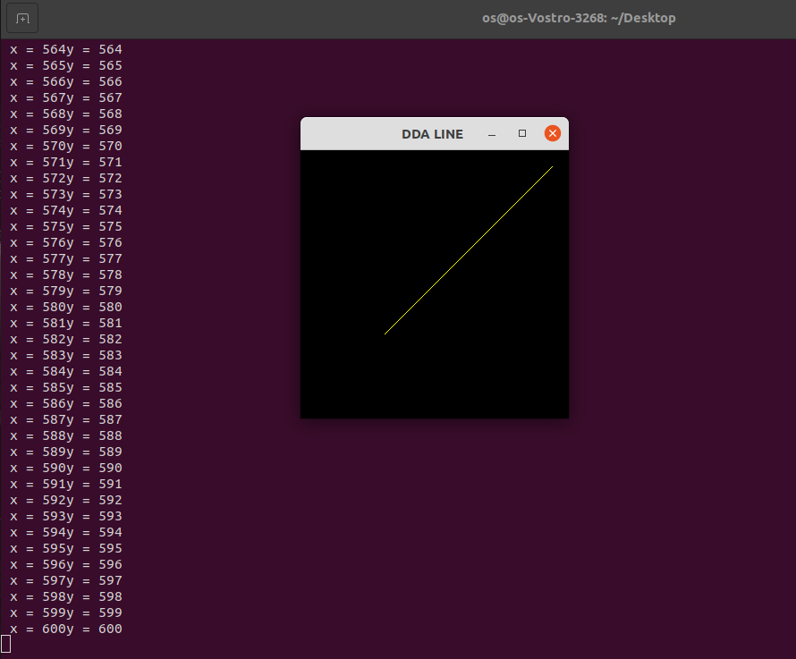

BRESENHAM CIRCLE

#include<stdio.h>
#include<math.h>
#include<GL/glut.h>

int xc = 320, yc = 240;

void plot_point(int x, int y){
glBegin(GL_POINTS);
glVertex2i(xc+x, yc+y);
glVertex2i(xc+x, yc-y);
glVertex2i(xc+y, yc+x);
glVertex2i(xc+y, yc-x);
glVertex2i(xc-x, yc-y);
glVertex2i(xc-x, yc+y);
glVertex2i(xc-y, yc-x);
glVertex2i(xc-y, yc+x);
glEnd();
}

void bresenham_circle(int r){
int x = 0, y = r;
float pk =(5.0, 4.0)-r;

plot_point(x,y);
int k;
while (x<y){
x = x+1;
if(pk<0)
pk = pk + 2*x+1;
else{
y = y-1;
pk = pk + 2*(x-y)+1;
}
plot_point(x,y);
}
glFlush();
}

void concentric_circles(void){
glClear(GL_COLOR_BUFFER_BIT);

int radius = 200;
bresenham_circle(radius);
}

void Init(){
glClearColor(1.0,1.0,1.0,0);
glColor3f(5.0,0.0,7.0);
gluOrtho2D(0,640,0,480);
}

int main(int argc, char **argv){
glutInit(&argc, argv);
glutInitDisplayMode(GLUT_SINGLE | GLUT_RGB);
glutInitWindowPosition(0,0);
glutInitWindowSize(640, 480);
glutCreateWindow("bresenham_circle");
Init();
glutDisplayFunc(concentric_circles);
glutMainLoop();
}

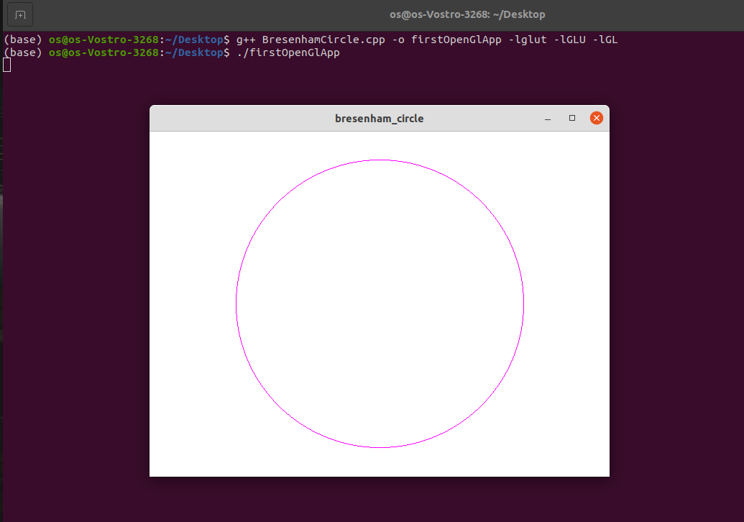

DDA LINE

#include<GL/glut.h>
#include<iostream>
#include<math.h>
using namespace std;
float r, g, b, x, y;
float x_1,x_2,y_1,y_2;
float xin, yin,length;
bool flag = true;
void mouse(int button,int state,int mousex,int mousey)
{
if(button == GLUT_LEFT_BUTTON
&& state == GLUT_DOWN){
flag = true;
x = mousex;
y = 640 - mousey;
}
}
int sgn(float a){
if(a == 0){
return 0;
}
if(a < 0){
return -1;
}
else
return 1;
}
void Line(){
cout<< "x_1="<<x_1<<"y_1="<<y_1;
cout<< "x_2="<<x_2<<"y_2="<<y_2;

float dy, dx, length;
x_2 = x;
y_2 = y;
dy = y_2 - y_1;
dx = x_2 - x_1;
if(abs(dx)>=abs(dy)){
length = abs(dx);
}
else{
length = abs(dy);
}
float xin, yin;
xin=(x_2 - x_1)/length;
yin=(y_2 - y_1)/length;
float x, y;
x=x_1+0.5*sgn(xin);
y=y_1+0.5*sgn(yin);

int i=0;
while(i<=length)
{
glBegin(GL_POINTS);
glVertex2i(x,y);
glEnd();
x=x+xin;
y=y+yin;
i++;
}
glFlush();
}
void init(void){
glClearColor(0,0,0,0);
glColor3f(1.0,1.0,0.0);
gluOrtho2D(0,640,0,640);
glClear(GL_COLOR_BUFFER_BIT);
}
int main(int argc, char** argv){
cout<<"Enter x1,y1 point";
cin>>x_1>>y_1;
glutInit(&argc,argv);
glutInitDisplayMode(GLUT_SINGLE| GLUT_RGB);
glutInitWindowSize(0,640);
glutCreateWindow("DDA LINE DRAWING TECHNIQUE");
init();
glutMouseFunc(mouse);
glutDisplayFunc(Line);
glutMainLoop();
return 0;
}

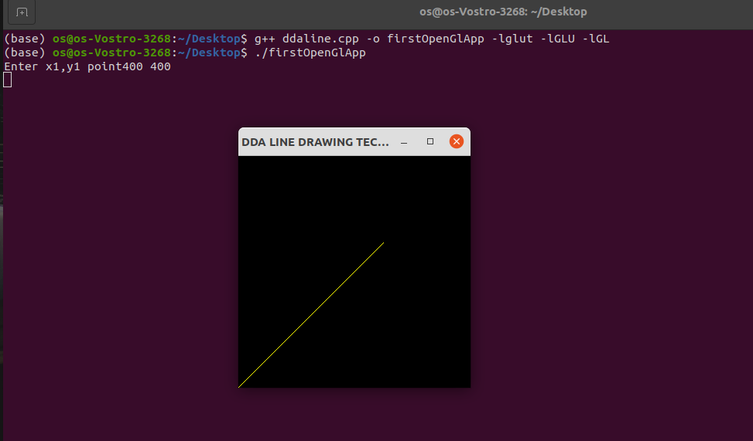

FLOOD FILL

#include<GL/glut.h>
#include<iostream>
#include<math.h>
int ww = 800, wh = 700;
float bgCol[3]={0.2,0.4,0.0};
float intCol[3]={0.0,0.0,1.0};
float fillCol[3] = {0.4 ,0.0,0.0};
void setPixel(int pointx, int pointy, float f[3])
{
glBegin(GL_POINTS);
glColor3fv(f);
glVertex2i(pointx, pointy);
glEnd();
glFlush();
}
void getPixel(int x, int y, float pixels[3])
{
glReadPixels(x, y, 1.0, 1.0,GL_RGB,GL_FLOAT, pixels);
}
void drawPolygon(int x1, int y1, int x2, int y2)
{
glColor3f(0.0,0.0,1.0);
glBegin(GL_POLYGON);
glVertex2i(x1,y1);
glVertex2i(x1,y2);
glVertex2i(x2,y2);
glVertex2i(x2,y1);
glEnd();
glFlush();
}
void display()
{
glClearColor(0.2,0.4,0.0,1.0);
glClear(GL_COLOR_BUFFER_BIT);
drawPolygon(150,250,200,300);
glFlush();
}
void floodfill4(int x, int y, float oldColor[3], float newcolor[3])
{
float color[3];
getPixel(x, y, color);
if(color[0]==oldColor[0]&&(color[1])==oldColor[1]&&(color[2])==oldColor[2])
{
setPixel(x, y, newcolor);
floodfill4(x+1, y,oldColor,newcolor);
floodfill4(x-1, y,oldColor,newcolor);
floodfill4(x, y+1,oldColor,newcolor);
floodfill4(x, y-1,oldColor,newcolor);
}
}
void mouse(int btn,int state, int x, int y)
{
if(btn==GLUT_LEFT_BUTTON && state == GLUT_DOWN)
{
int xi = x;
int yi = (wh - y);
floodfill4(xi, yi, intCol, fillCol);
}
}
void myinit()
{
glViewport(0,0,ww,wh);
glMatrixMode(GL_PROJECTION);
glLoadIdentity();
gluOrtho2D(0.0,(GLdouble)ww,0.0,(GLdouble)wh);
glMatrixMode(GL_MODELVIEW);
}
int main (int argc , char **argv)
{
glutInit(&argc,argv);
glutInitDisplayMode(GLUT_SINGLE|GLUT_RGB);
glutInitWindowSize(ww , wh);
glutCreateWindow("Flood Fill Recursive");
glutDisplayFunc(display);
myinit();
glutMouseFunc(mouse);
glutMainLoop();
return 0;
}

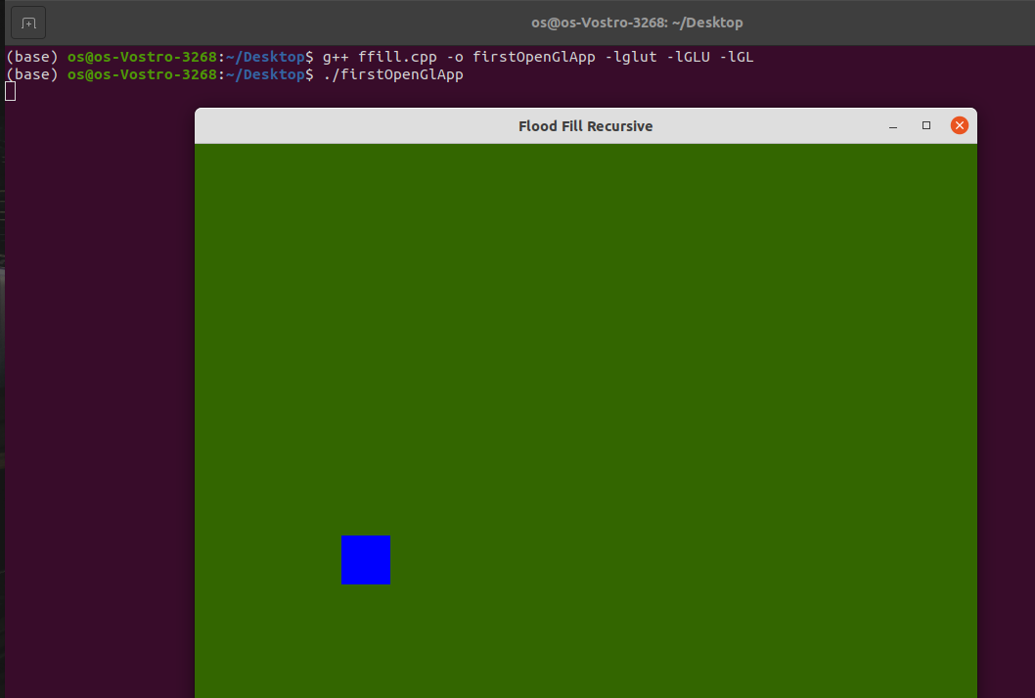

SQUARE

#include <GL/glut.h>
void init() {
glClearColor(0.0,0.0,0.0,0.0);
glOrtho(0.0,1.0,0.0,1.0,-1.0,1.0);
glLoadIdentity();
}
void display() {
glClear(GL_COLOR_BUFFER_BIT);
glColor3f(0.0,0.0,1.0);
glBegin(GL_LINE_LOOP);
glVertex3f(0.25,0.25,0.75);
glVertex3f(0.75,0.25,0.25);
glVertex3f(0.75,0.75,0.25);
glVertex3f(0.25,0.75,0.75);

glEnd();
glFlush();
}
int main(int argc, char** argv){

glutInit(&argc, argv);
glutInitDisplayMode(GLUT_SINGLE | GLUT_RGB);
glutInitWindowSize(0, 600);
glutCreateWindow("DDA Line");
init();
glutDisplayFunc(display);
glutMainLoop();
return 0;
}

